Analyzing City Hotel Bookings in Portugal (2016)
Exploratory Data Analysis
Name: Raneem Aqel

Business Problem

Hotels operate on a constant flow of guests, but booking cancellations create a persistent challenge, impacting potential revenue and room availability optimization. This project explores a detailed dataset to understand the factors influencing booking outcomes, examining customer behavior in both canceled and confirmed bookings.

Business Impact

This analysis will empower hotels to minimize cancellations and enhance customer satisfaction through data-driven insights. By uncovering the statistical relationships between cancellations and key booking factors—including lead time, ADR, room type, waiting list days, and booking channel. Hotels can implement targeted strategies to optimize pricing, policies, and marketing efforts. Furthermore, understanding the preferences of confirmed bookings will enable hotels to refine their offerings and strengthen customer relationships, leading to increased revenue and improved customer loyalty.
Steps of Exploratory Data Analysis
- Target Feature & Columns of Interest:

- Target feature(s): Boolean: True if the booking was canceled, False otherwise. This will be the primary focus of our analysis, aiming to understand the factors that contribute to booking cancellations.
- Columns of Interest:
- lead_time: What is the distribution of lead times for total bookings and canceled bookings?
- Adr: in this variable we will explore the average ADR and how it is correlated with number of bookings for total bookings and canceled bookings.
- days_in_waiting_list: What is the distribution of waiting list days? Is there a relationship between days in waiting list and canceled bookings?
- arrival_date_month: How are total bookings distributed across different months? Are there peak seasons? What is the cancellation rate for each month? Are there months with significantly higher cancellation rates? (Calculate cancellation rates per month, bar chart).
- distribution_channel: What are the most common distribution channels? Do cancellation rates differ significantly across distribution channels?
- market_segment: What are the most common market segments? Do cancellation rates differ significantly across market segments?
- customer_type: What are the most common customer types? Do cancellation rates differ significantly across customer types?
- deposit_type: What are the most common deposit types? Do cancellation rates differ significantly across deposit types?
- Null Values Percentage, Basic Numerical Stats, Sub-group Categorical Size, distribution and correlations:
- Using Python data profiling library: below attachments are showing detailed information about each variable with visualization for both total bookings and canceled bookings.
Total Bookings: (download the file)
https://drive.google.com/file/d/1v7YFAJy7bWr5SVMeEhcvR8GVK9LgneuF/view?usp=drive_link
Canceled Bookings: (download the file)
https://drive.google.com/file/d/1IZg2eJCfll3_DIL1FQ3xlBoIY7PUnnfG/view?usp=drive_link

- Outcomes:
- Confirmed Bookings vs Canceled Bookings from total hotel bookings: This initial overview highlights a significant proportion of cancellations (40%).

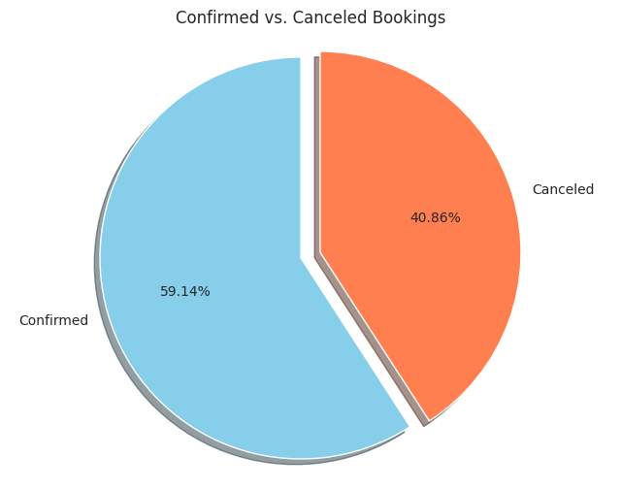
- Lead Time Distribution on Total Hotel Bookings & Canceled Bookings
The histogram for all bookings reveals a right-skewed distribution, with a majority of bookings made with short lead times. This indicates a strong preference for last-minute bookings among guests. The histogram for canceled bookings, while also right-skewed, shows a more pronounced concentration at very short lead times.
- ADR Distribution on Total Hotel Bookings & Canceled Bookings
Comparing the ADR distributions of total and canceled bookings reveals that cancellations are concentrated at lower ADR. This suggests that price sensitivity is a key factor, with guests booking less expensive rooms being more likely to cancel. Below Scatter Plots support the analysis.
Total Bookings:
https://drive.google.com/file/d/1OKcSl8zPJ5Bc57uQNmP1J9cqlat-iOGm/view?usp=drive_link
Canceled Bookings:
https://drive.google.com/file/d/1W1MW3G1L3uv6t5PPdBvynPMBHqFPbVyj/view?usp=drive_link
- Days in Waiting List Distribution on Total Hotel Bookings & Canceled Bookings
The analysis of the "days in waiting list" histograms leads us to reject the hypothesis that long waiting list days are a primary driver of cancellations. The overwhelming majority of bookings are confirmed immediately, and the number of cancellations associated with longer waits is relatively small.

- Confirmed Bookings vs Canceled Bookings by Month:
The data reveals a clear seasonal pattern with October as the peak month for both total and canceled bookings, followed by a strong summer season including August. The winter months represent the off-season.
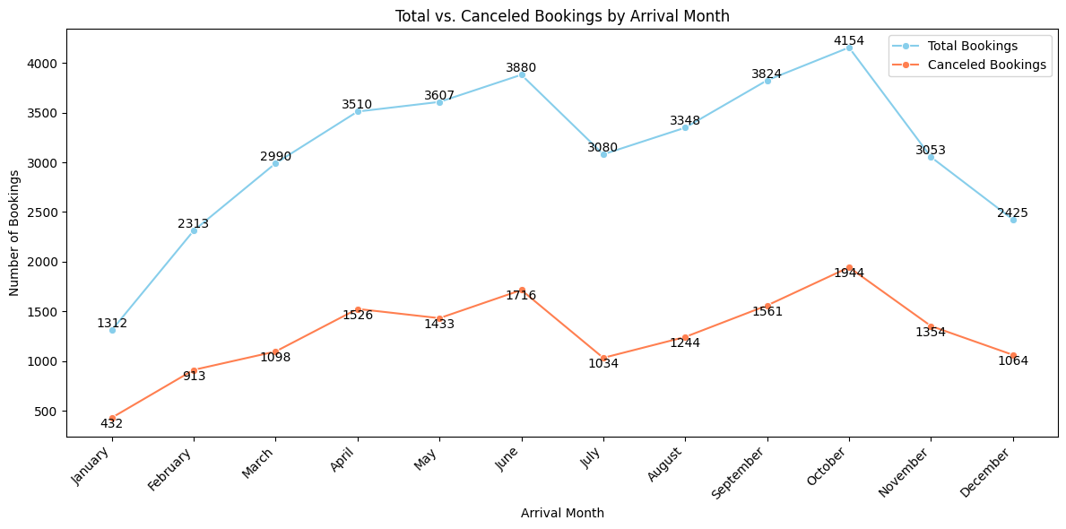
- Having determined that high ADR, and days in waiting list do not exhibit a significant correlation with cancellation rates, further investigation into categorical variables is necessary to identify key factors influencing cancellations.

- Total Bookings vs Canceled by Distribution Channel
The TA/TO channel is the primary source of bookings and cancellations for the hotel with the highest rate of cancelation (34%) from total bookings.
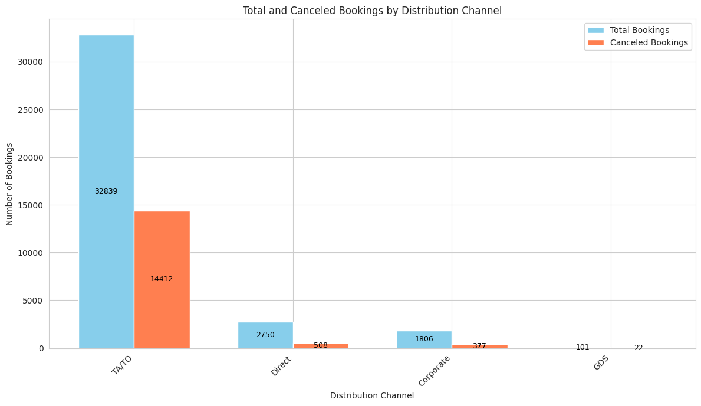

Given the dominance of the TA/TO channel, we will now analyze its internal market segmentation, Customer Type, and deposit type to understand cancellation drivers

- TA/TO Distribution Channel Total Bookings vs Canceled by Market Segmentation
The bar chart shows that "Online TA" and "Offline TA/TO" are the dominant market segments within the TA/TO distribution channel, accounting for the majority of both total bookings and cancellations. While the "Groups" segment has a lower volume of bookings compared to these two, it's important to note that it still represents a significant portion of the hotel's business.

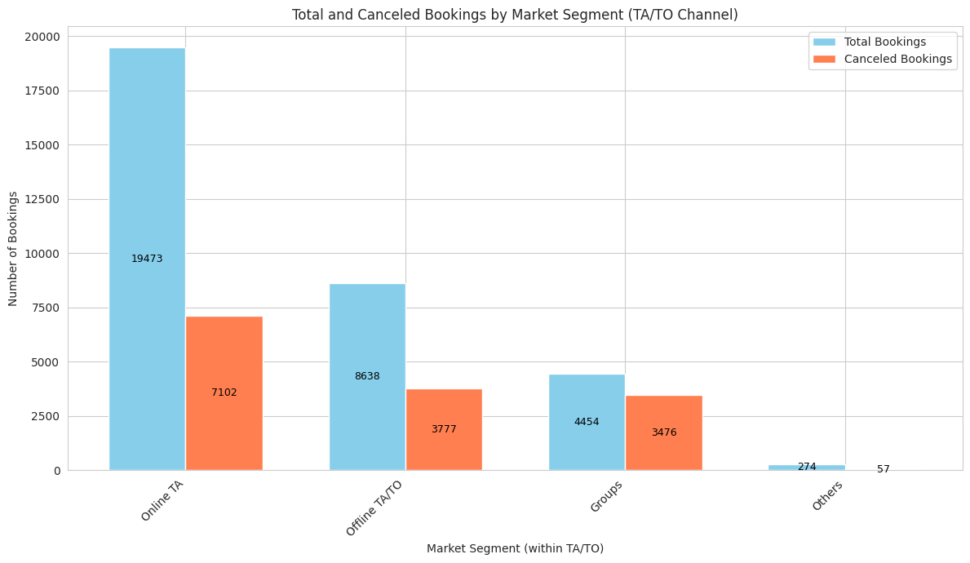

- TA/TO Distribution Channel Total Bookings vs Canceled by Customer Type
Transient is the dominant customer type within the TA/TO channel, with a significantly higher number of total bookings compared to all other customer types with the highest number of canceled bookings.
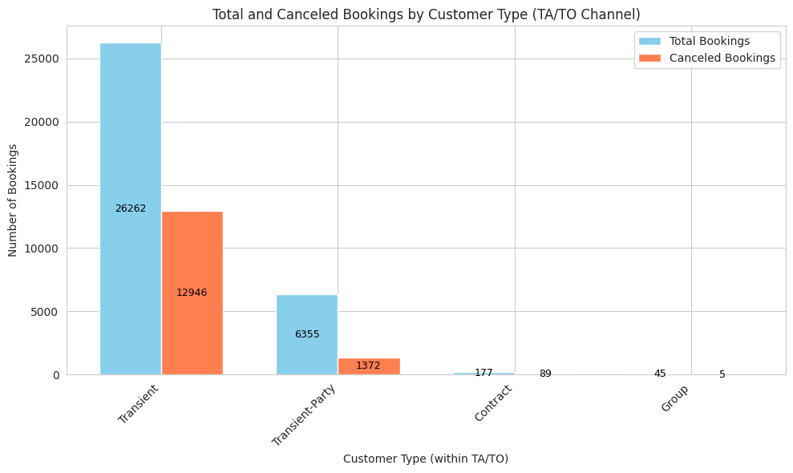

- TA/TO Distribution Channel - Transient Total Bookings vs Canceled by Deposit Type:
The chart is showing that the majority of the bookings are made with no deposits with high number of cancelation and made through TA/TO (Online TA), also the chart is indicating that all the “non-refund” bookings (deposit was made in the value of the total stay cost) are canceled, these bookings are categorized under market segmentation “Groups”.

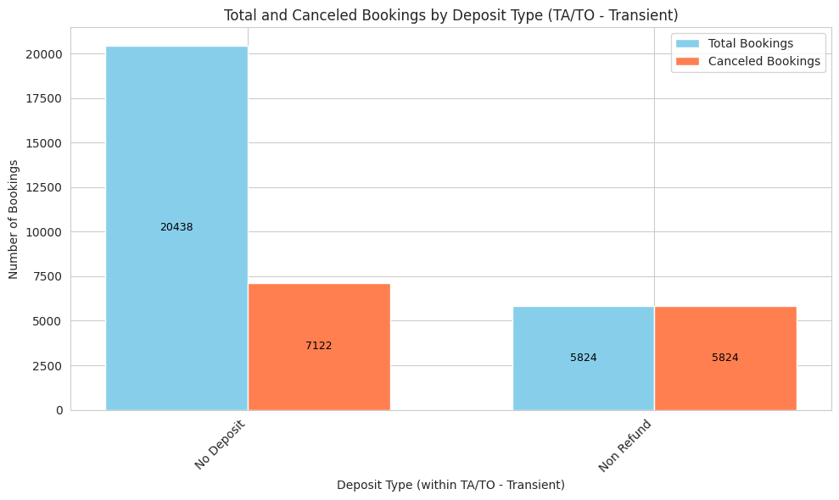
- TA/TO Distribution Channel - Transient Lead Time Histogram for Canceled Bookings by market segmentation (Online TA, Offline TA/TO, & Groups):

Lead time does indeed influence cancellation patterns, with shorter lead times increasing the likelihood of cancellation for Online TA bookings and longer lead times being more common for canceled Group bookings.

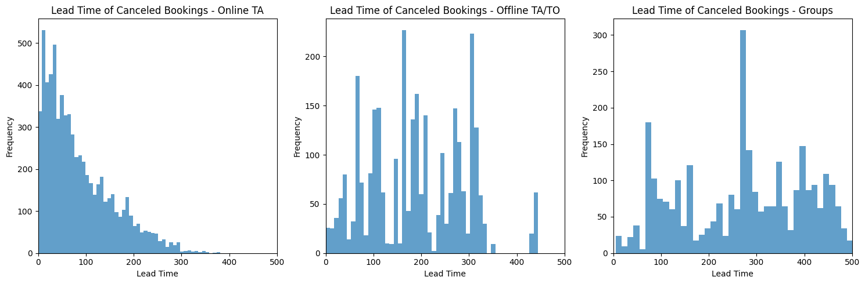

- TA/TO Distribution Channel - Transient ADR Box Plot for Canceled Bookings by market segmentation (Online TA, Offline TA/TO, & Groups):
Based on the box plot of ADR for canceled bookings, there is a potential correlation between higher prices and increased cancellations, particularly for Online TA bookings.
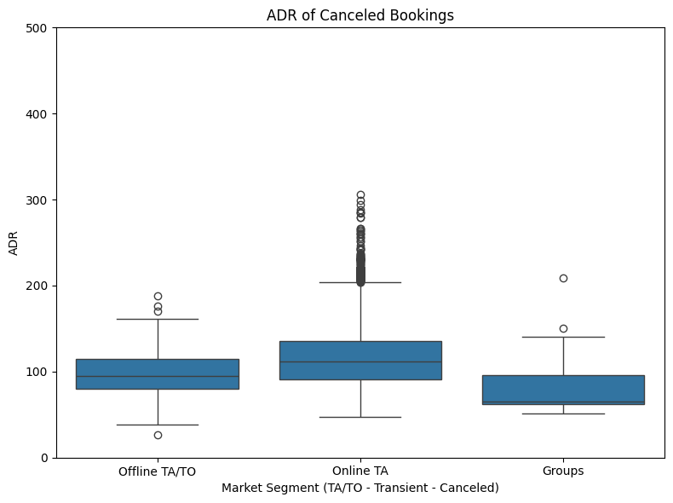
In Conclusion:
- Deposit Type and Cancellations: "No Deposit" bookings have a significantly higher cancellation rate than "Non Refund" bookings.
- Market Segment Differences:
- Online TA: Highest ADR, but also the highest cancellation rate, shorter lead times and a concentration of cancellations closer to arrival.
- Offline TA/TO: Moderate ADR and a more variable cancellation rate, longer lead times and cancellations spread across a wider time frame.
- Groups: Lowest ADR and the longest lead times, very high cancellation rate within groups bookings, often occurring well in advance.
- Lead Time and Cancellations:
- Lead time is a significant factor influencing cancellations, shorter lead times are associated with higher cancellation rates, especially for Online TA. Longer lead times are more common for canceled Group bookings.
- ADR and Cancellations:
- There's a potential correlation between higher ADR and increased cancellations, particularly for Online TA.
CSV file: https://drive.google.com/file/d/13d4hX_OHOkxJVGoNG_p9TRXPxM653tY-/view?usp=drive_link
Colab: https://colab.research.google.com/drive/143qoxt4p_uwcDBmO59ICx5AAfV_q_L-U?usp=drive_link

